**Support Documentation**

This section has been divided into multiple to show a better understanding and quality of each section in this notebook.

Offensive/Defensive

Figure 1.1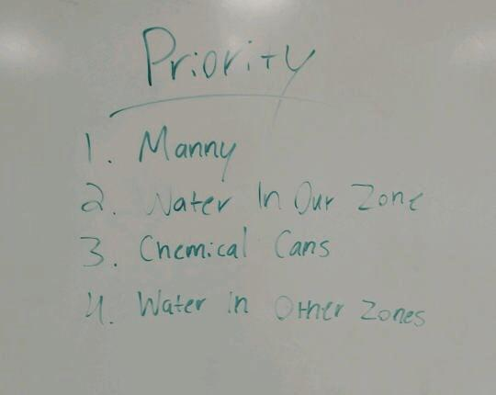

Shows our game plan at the beginning which our thoughtfulness the strategies at the beginning

Figure 1.2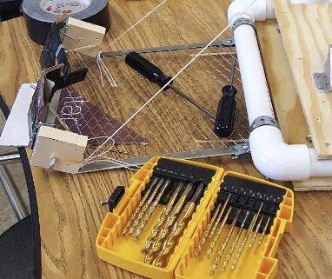

Our gate which it will be able to do the first tasks in this case rescuing Manny and later on the chemical cans

Brainstorming

Figure 2.1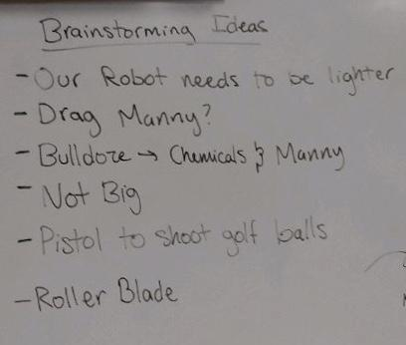

After knowing the certain task we have to think about how to do them. Figure 2.1 shows our way of taking our time to make the robot efficient.

Figure 2.2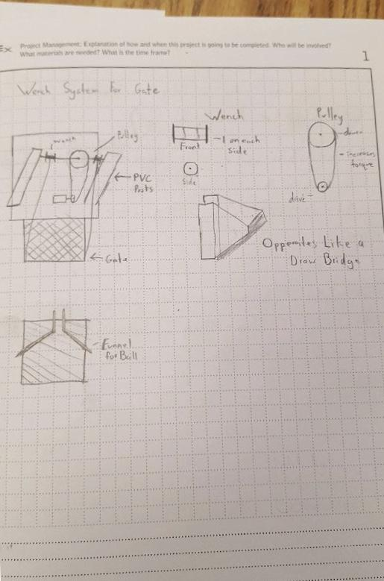

Sketches of the different components of our robot

Design Process/Construction

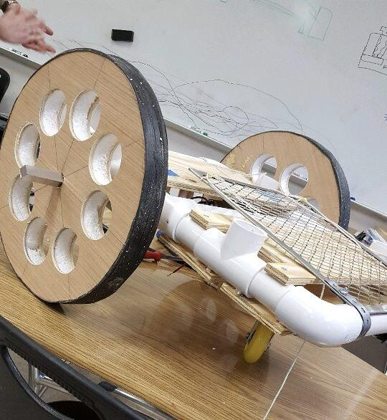

Figure 3.1

Shows our standard base with mounted wheels and gate

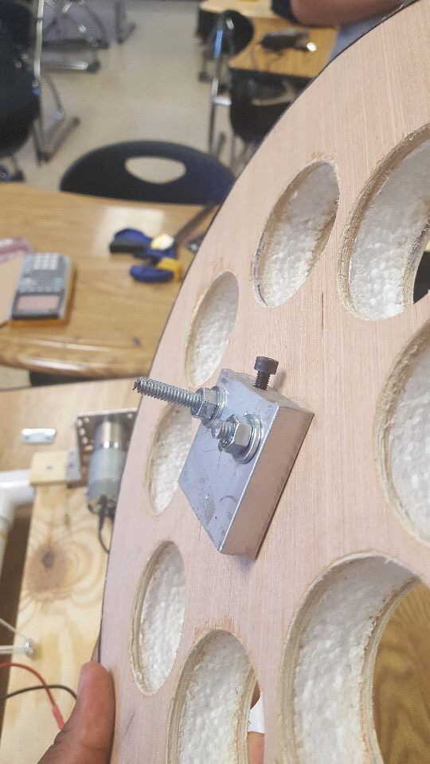

Figure 3.2

Wheel with the motor connector ready to be mounted

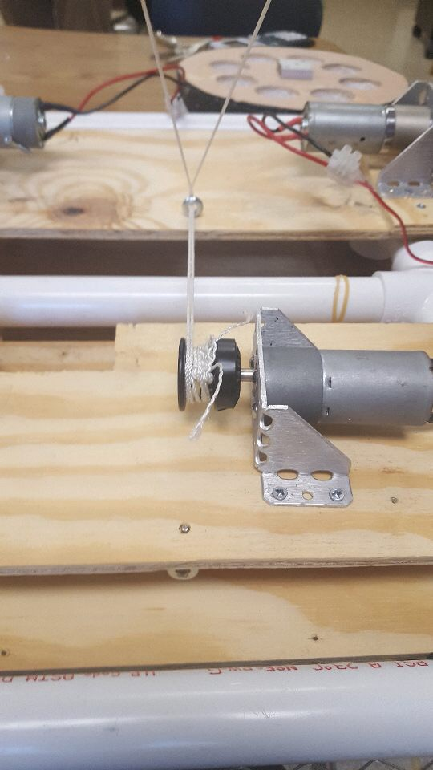

Figure 3.3

Shows our motor mounts for gate and wheels

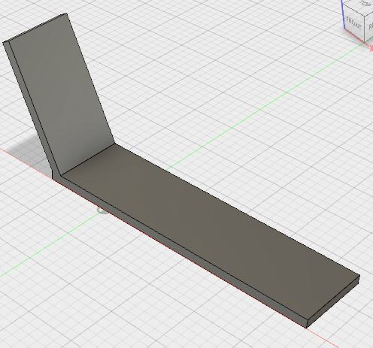

Figure 3.4

CAD drawing for the winch which is attached to the gate

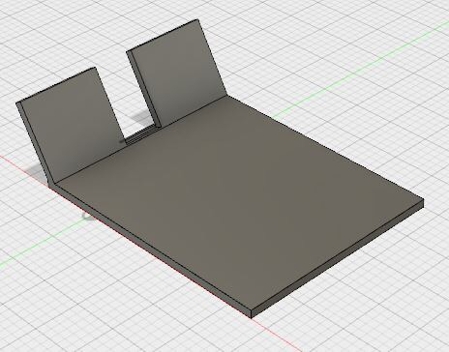

Figure 3.5

CAD drawing for gate with winches attached

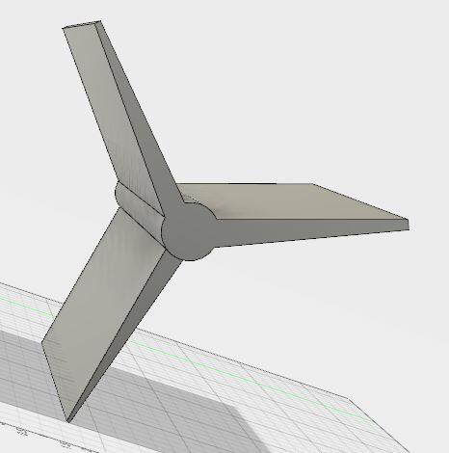

Figure 3.6

CAD drawing for a special piece in our shooting mechanism

Math/Alternates

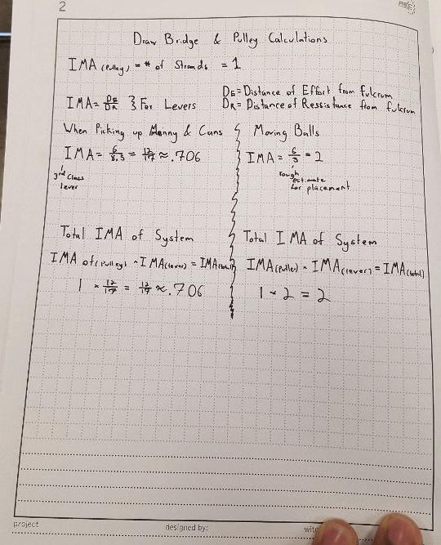

Figure 4.1

IMA calculations for drawbridge and pulley

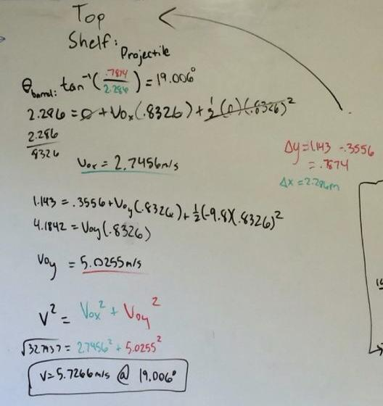

Figure 4.2

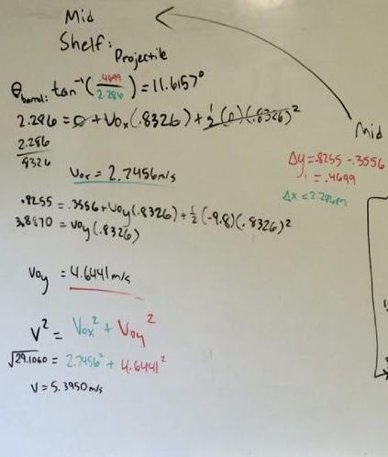

Figure 4.3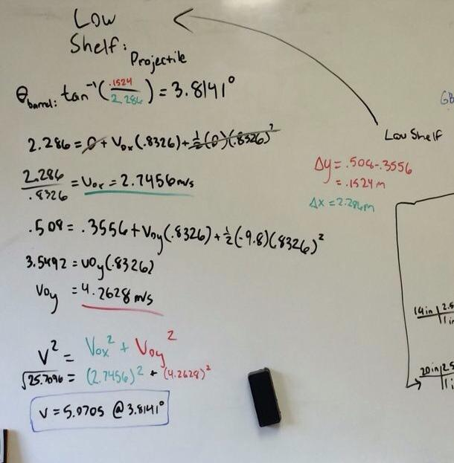

Figure 4.4

For Figure 4.2,3,4 we demonstrate our calculation for the firing mechanism through projectile motion physics.

Safety

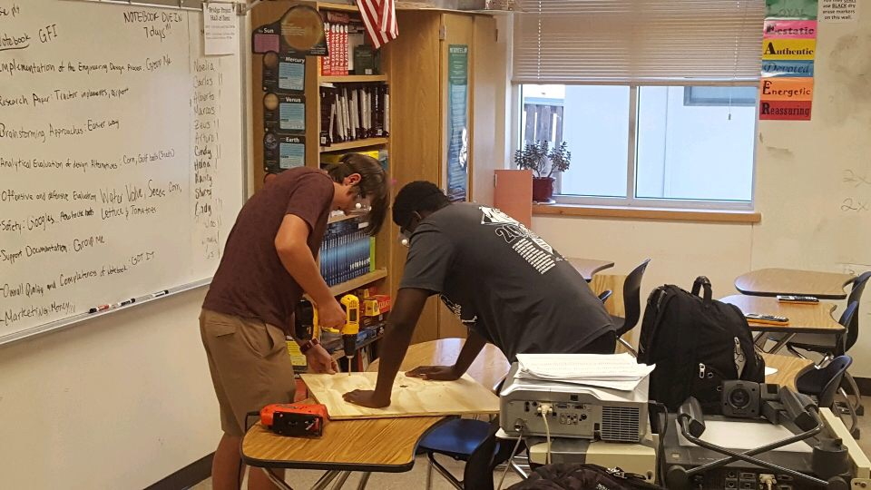

Figure 5.1

Demonstrates effective safety procedures taking place

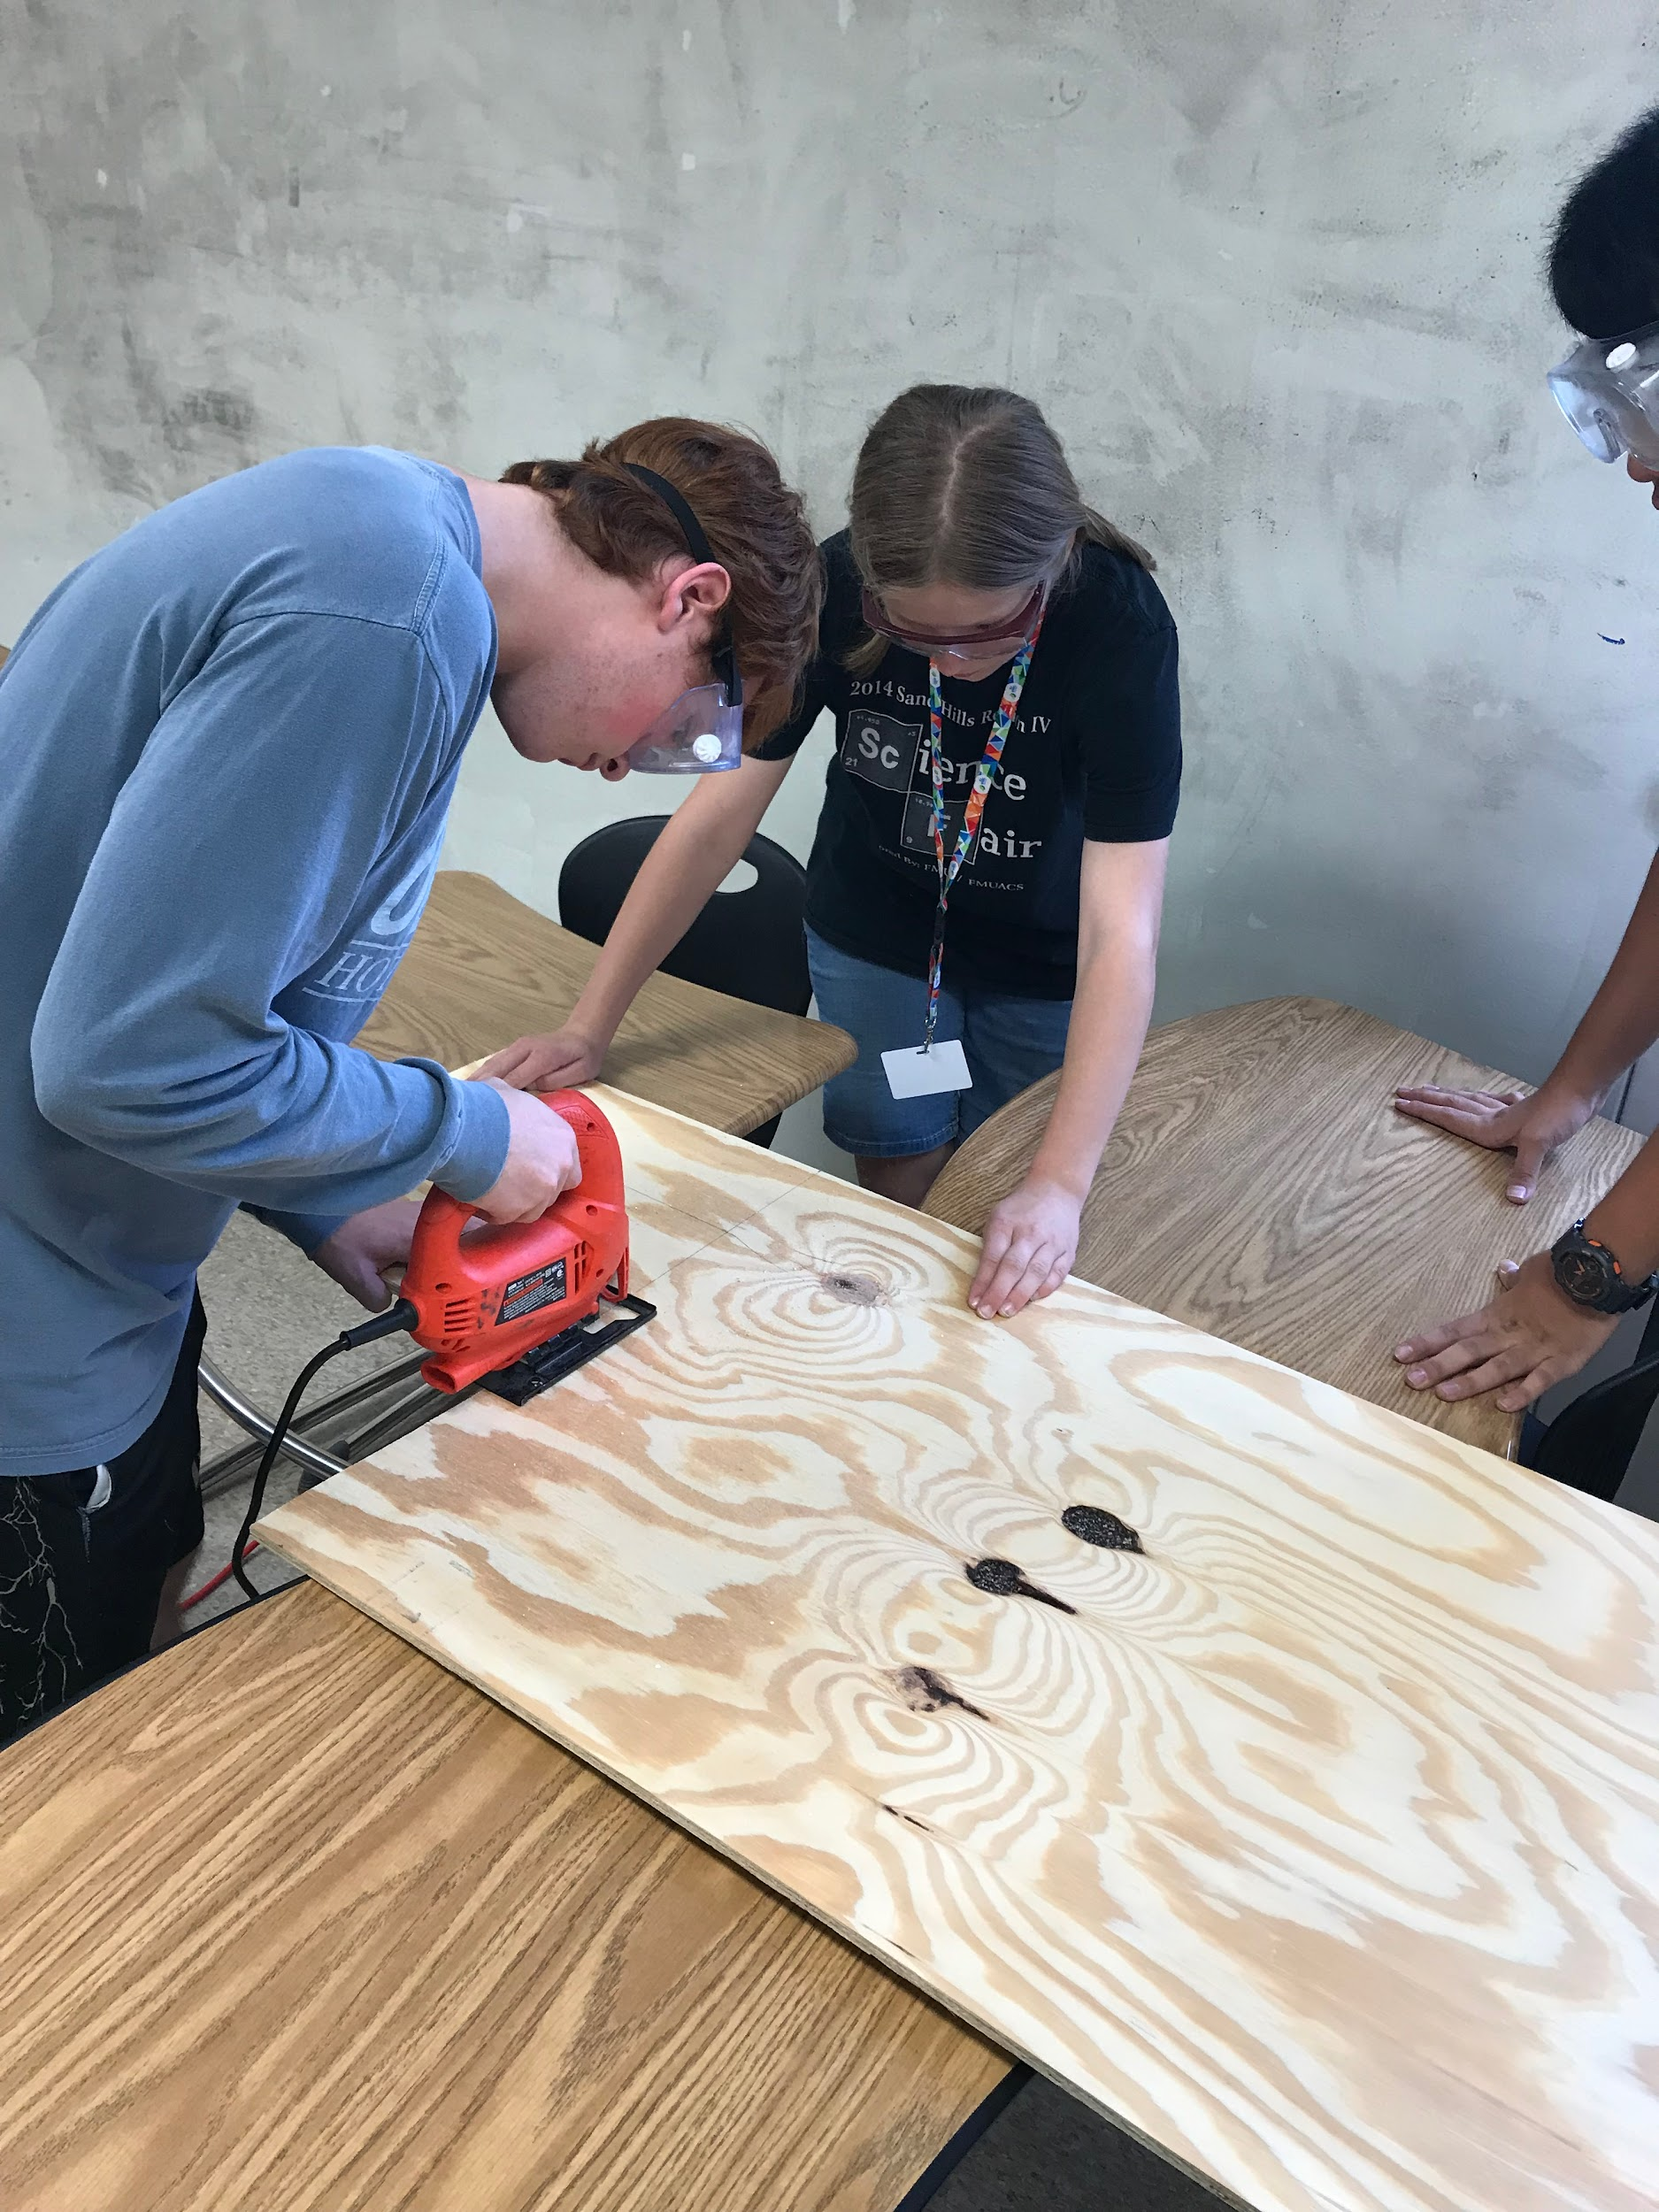

Figure 5.2

Like Figure 5.1 it shows precaution of safety

